(UDPN Whitepaper Working Draft)

The Universal Digital Payment Network (UDPN) is a global DLT infrastructure that standardizes digital currency payments and allows any business to process digital payments in regulated fiat-backed stablecoins as well as Central Bank Digital Currencies (CBDCs). The UDPN network will be operated by the UDPN Alliance, a consortium of leading financial institutions and technology companies. The network is powered by a set of four nodes to serve its purpose. Validator Nodes and Transaction Audit and Reporting (TAR) Nodes are located on-chain while Business Nodes and Transaction Nodes are off-chain gateways that connect to the UDPN network. Validator Nodes will ensure the messages sent over the network follow the network format and enable on-chain governance, while TAR Nodes will ensure regulators and auditors can properly monitor all transactions powered by the network. Business Nodes allow third-party businesses to connect their IT systems to the UDPN and offer digital currency services to their customers. Transaction Nodes connect to digital currency systems and execute transactions validated on UDPN.

Executive Summary

**The proliferation in development, testing and launch of regulated digital currencies – those issued or approved by Central Banks – continues its acceleration unabated. As an increasing number of these currencies come online, how can we build a cutting-edge network infrastructure that enables interoperability between currency systems, while allowing for seamless distribution and lowered cost for payments?**

The last few years have seen a seismic shift across the financial sector. It has been driven by the need to promote financial inclusion, increase competition and to fix broken payment infrastructure. Central Banks across the globe are having to reorganise the structure of their respective banking systems, leading to fundamental changes in how commercial banks intermediate payments. With the proliferation of FinTech, individuals and businesses are gaining ever increasing control over their individual accounts.

The global payments’ ecosystem is seeing a rise in the development of digital currency, including the increase in both occurrence and use of fiat-backed stablecoins. Interest in Central Bank Digital Currencies (CBDCs) has also accelerated with increased levels of research & development into CBDCs being seen across the globe. These digital currencies offer many benefits: from improved ease of transactions, speed, transparency, and liquidity to enhanced resilience and cost savings. They are also improving the availability of money (including to the underbanked and unbanked population).

Despite the surge in interest, a lack of standardisation, and the absence of a common messaging language, threaten to handicap this growth of stablecoins and CBDCs. The incumbent legacy infrastructure aside, the challenge of interoperability between different digital currency protocols is currently the greatest problem facing the growth of digital currencies globally. Scalable and universal interoperability will be key to enabling the efficient movement of digital currency between the legacy payments infrastructure and the rapidly evolving digital currency systems. This will also be needed for interoperability between future currency systems, namely CBDC to CBDC as well as CBDC to stablecoins and vice versa.

The Universal Digital Payment Network (UDPN) addresses this issue by creating a global payment messaging network, designed to support regulated, fiat-backed stablecoins and CBDCs across decentralised and centralised currency systems. The goal of the UDPN is to create a common decentralised network and associated standards: a global infrastructure to power real-time payments in any regulated and non-speculative digital currency. .

**Key Features and Benefits of the UDPN include:**

1. Provision of a common standard for messaging across different digital currency systems, facilitating interoperability functions between CBDC and fiat-backed stablecoin ecosystems.

2. It enables all types of commercial enterprise, across the globe, to transact and settle in different currencies, allowing them to easily integrate with multiple digital payment systems. They can connect to the UDPN via their locally installed business nodes, and thus easily access the CBDC and Stablecoin currency systems.

3. It does not serve individual end-consumers directly, but rather provides the core digital infrastructure to software engineers and programers who can build applications involving digital currency payments in a comparatively low-cost and convenient manner.

4. It supports only CBDCs and regulated fiat-backed stablecoin currency systems as payment methods. No unregulated public-chain cryptocurrencies, such as Bitcoin, will be accepted. The addition of any new currency is subject to a vote by the UDPN Alliance members as part of the network’s decentralised governance approach.

5. Presenting a way for commercial banks to actively participate in the decentralised economy. Banks will provide capital pools and engage with their local Central Banks to offer liquidity for the cross-border foreign exchange transactions.

6. The UDPN will be managed by an alliance of financial institutions and technology companies from different countries and industry verticals, each having shared ownership of the network

7. It does not provide any custodial services. Nor does it hold or move any digital currencies.

8. The UDPN permissioned network has four main nodes: The Validator Nodes and TAR Nodes are on-chain whereas the Business and Transaction Nodes of the UDPN are off-chain. The Validator Nodes contain the Hyperledger BESU peer, validator and governance systems, with the Transaction Audit and Reporting (TAR) Nodes containing the BESU Archive Node. Business Nodes connect business IT systems to the UDPN while Transaction Nodes connect to different stablecoin and CBDC systems.

9. Each Node has a distinct set of attributes and is run by different stakeholders from Business Enterprises, regulated Financial Institutions, Regulators and UDPN Alliance members, respectively.

10. The beta testnet of the UDPN is scheduled to go live with two to five stablecoins in late 2021, with pilot commercialisation by early 2022. In the medium to long term, the UDPN should support the majority of the world's CBDCs and stablecoins.

11. The UDPN’s design gives it the potential to facilitate transaction messaging between a variety of account systems, not just CBDCs and stablecoins. It can also support commercial bank accounts and traditional payment accounts; thus, providing a messaging bridge that connects fiat-money systems with digital currency systems.

The UDPN is being built for both the present and the future. CBDCs and stablecoins are anticipated to become an integral part of the cross-border payment ecosystem. The UDPN is ideally placed to be the primary choice for Central Banks when it comes to the distribution of their own digital currencies. The same is true for enterprises looking to transfer or swap digital currencies. With the UDPN, the evolving payments ecosystem can move towards a vastly improved and more resilient future which is in sync with the development of emerging technologies.

Universal Digital Payments Network (UDPN)

1. Introduction 5

1.1. Background 5

[1.2. Objectives of UDPN 8](https://docs.google.com/document/d/1AgNnAHNybTHKLf04ViwZVDD-IwLfMlYQ/edit#heading=h.3dy6vkm)

[2. Fundamental Architecture & Operation Model 11](https://docs.google.com/document/d/1AgNnAHNybTHKLf04ViwZVDD-IwLfMlYQ/edit#heading=h.4d34og8)

[2.1. Underlying Framework of the UDPN 11](https://docs.google.com/document/d/1AgNnAHNybTHKLf04ViwZVDD-IwLfMlYQ/edit#heading=h.2s8eyo1)

[2.2. Permissioned Decentralised Network 11](https://docs.google.com/document/d/1AgNnAHNybTHKLf04ViwZVDD-IwLfMlYQ/edit#heading=h.17dp8vu)

[2.3. Stakeholders and Node Types 12](https://docs.google.com/document/d/1AgNnAHNybTHKLf04ViwZVDD-IwLfMlYQ/edit#heading=h.35nkun2)

[2.3.1. UDPN Decentralised Identity (DID) 12](https://docs.google.com/document/d/1AgNnAHNybTHKLf04ViwZVDD-IwLfMlYQ/edit#heading=h.1ksv4uv)

[2.3.2. UDPN Nodes 13](https://docs.google.com/document/d/1AgNnAHNybTHKLf04ViwZVDD-IwLfMlYQ/edit#heading=h.44sinio)

[2.3.3. Smart Contracts 17](https://docs.google.com/document/d/1AgNnAHNybTHKLf04ViwZVDD-IwLfMlYQ/edit#heading=h.3j2qqm3)

[2.4. Revenue Model 18](https://docs.google.com/document/d/1AgNnAHNybTHKLf04ViwZVDD-IwLfMlYQ/edit#heading=h.4i7ojhp)

[3. Transaction Flows 19](https://docs.google.com/document/d/1AgNnAHNybTHKLf04ViwZVDD-IwLfMlYQ/edit#heading=h.2xcytpi)

[3.1. Creation of UDPN DID 19](https://docs.google.com/document/d/1AgNnAHNybTHKLf04ViwZVDD-IwLfMlYQ/edit#heading=h.1ci93xb)

[3.2. Linking/delinking CDBC and Stablecoin Wallets 20](https://docs.google.com/document/d/1AgNnAHNybTHKLf04ViwZVDD-IwLfMlYQ/edit#heading=h.3whwml4)

[3.3. Digital Currency Transfers & Currency Swaps 21](https://docs.google.com/document/d/1AgNnAHNybTHKLf04ViwZVDD-IwLfMlYQ/edit#heading=h.qsh70q)

[3.4. Refund Process in the case of a failed transfer 22](https://docs.google.com/document/d/1AgNnAHNybTHKLf04ViwZVDD-IwLfMlYQ/edit#heading=h.3as4poj)

[4. Wholesale Currency Settlement Token 24](https://docs.google.com/document/d/1AgNnAHNybTHKLf04ViwZVDD-IwLfMlYQ/edit#heading=h.49x2ik5)

[5. Security and Privacy 25](https://docs.google.com/document/d/1AgNnAHNybTHKLf04ViwZVDD-IwLfMlYQ/edit#heading=h.3o7alnk)

[5.1. IT Security 25](https://docs.google.com/document/d/1AgNnAHNybTHKLf04ViwZVDD-IwLfMlYQ/edit#heading=h.ihv636)

[5.2. Privacy 26](https://docs.google.com/document/d/1AgNnAHNybTHKLf04ViwZVDD-IwLfMlYQ/edit#heading=h.1v1yuxt)

[5.3. Know Your Customer (KYC) Rules 27](https://docs.google.com/document/d/1AgNnAHNybTHKLf04ViwZVDD-IwLfMlYQ/edit#heading=h.2u6wntf)

[6. Regulatory Compliance 29](https://docs.google.com/document/d/1AgNnAHNybTHKLf04ViwZVDD-IwLfMlYQ/edit#heading=h.19c6y18)

[7. UDPN Alliance & Governance 30](https://docs.google.com/document/d/1AgNnAHNybTHKLf04ViwZVDD-IwLfMlYQ/edit#heading=h.28h4qwu)

[7.1. Organisation & Founding Members 30](https://docs.google.com/document/d/1AgNnAHNybTHKLf04ViwZVDD-IwLfMlYQ/edit#heading=h.nmf14n)

[7.2. Decentralised Governance and Voting 30](https://docs.google.com/document/d/1AgNnAHNybTHKLf04ViwZVDD-IwLfMlYQ/edit#heading=h.46r0co2)

[8. Social Impact 32](https://docs.google.com/document/d/1AgNnAHNybTHKLf04ViwZVDD-IwLfMlYQ/edit#heading=h.3l18frh)

[9. Roadmap 33](https://docs.google.com/document/d/1AgNnAHNybTHKLf04ViwZVDD-IwLfMlYQ/edit#heading=h.4k668n3)

[10. Conclusion 34](https://docs.google.com/document/d/1AgNnAHNybTHKLf04ViwZVDD-IwLfMlYQ/edit#heading=h.3ygebqi)

# Introduction

## **Background**

In a world driven by technology, we are witnessing a major transition in the way that central banks, financial institutions, and end users conduct financial transactions. The advent of SWIFT in the late 1970s enabled and facilitated a great rise in cross border, bank-to-bank, financial transactions which now run into trillions of dollars every day. This cross-border payment set-up, although revolutionary at the time, is not compatible with the rapid changes being brought about by the evolution of the finance industry. Innovations in FinTech, digital currencies and decentralised finance demand a new standard for transactions and payments, one which is faster, safer and programmable. The rapid transformation of the payment industry presents businesses with new opportunities to assist their customers in their payment journeys and improve client experience by offering instant and efficient payment services at a low cost. Beyond serving as trusted custodians in the case of commercial banks, financial institutions and regulated fintechs will play a key role in the future of digital payments from facilitating the distribution of CBDCs to reducing settlement risks.

Cross-border transactions today represent 15-20% of total e-commerce activity and this share is expected to grow substantially in the coming years[1]. Annual remittances have exceeded US $700 Billion in recent years[2] and, whilst there is a short term drop in international travel due to the pandemic, international migration and travel have grown by 53% in the last decade, placing further demand on cross-border payment infrastructures[3].

Cross-border payments today are subject to slow processing and high costs due to the fragmented nature of the international bank accounts system. With the rise of digital currencies, correspondent banks will have to adapt their operating processes to serve a new generation of digital customers, who expect instant, automated, and secure payment methods.

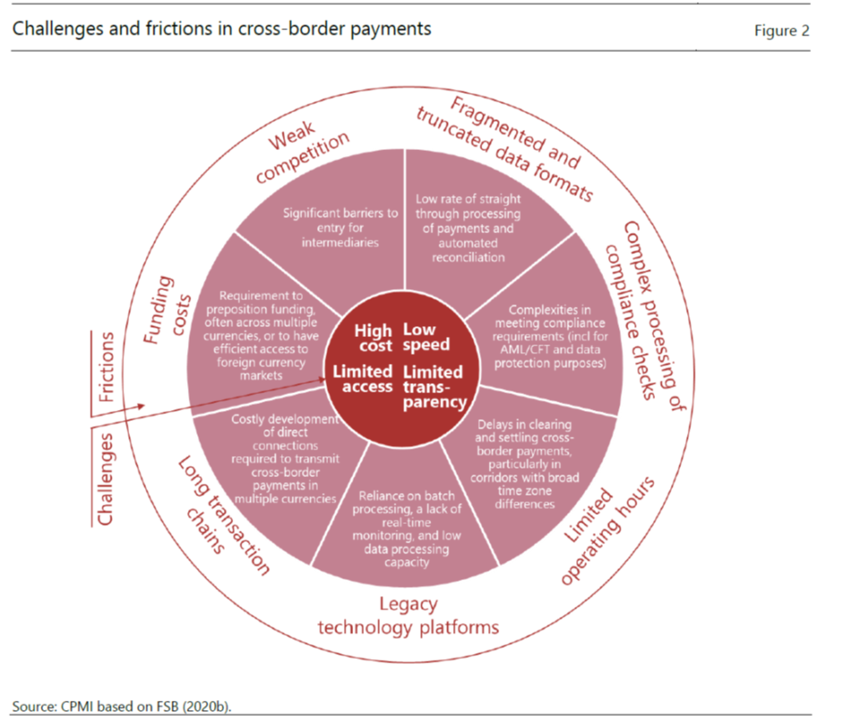

Fees average 7% for cross border remittances[4]. Businesses with the right partners have the opportunity to charge a fraction of these fees leveraging distributed ledger technologies and smart contracts to enhance their customers’ understanding of the payments journey. Banks are creating innovative business models to stay relevant in the digital era. Additionally, commercial banks have the opportunity to enhance transparency across the payment supply chain and reduce transaction settlement time with the right technologies to enhance their customer’s experience. . The rise of the smartphone has brought about an exponential increase in mobile payments globally. FinTech firms are disrupting the traditional market, utilising digital technologies to lower costs and increase the speed of transactions. The increasing popularity of wearable technologies and hands-off payments (further bolstered by an increased focus on hygiene during the Covid-19 pandemic) is expected to contribute to an increase in the number of people favouring the use of digital payment methods over physical cash. The move from cash to cashless is expected to become omnipresent for consumers everywhere in a few years’ time. Four in five (83%) Europeans say (to varying degrees) that they use cash less since they have started to use contactless payments, illustrating how technology is influencing behaviour [5]. In the UK, usage of cash dropped from 63% in 2006 to 28% in 2018[6]. Already many places globally, including Sweden and a significant portion of urban China, have turned almost entirely cashless.

In parallel to this growth in digital payments, the last 5 years has also seen a significant rise in the development and use of Distributed Ledger Technologies (DLT) for conducting payments. Financial institutions, including Central Banks, have come to embrace the value of using digital currencies for cross-border payments, thereby enabling a low friction approach for transacting outside of the more traditional payment systems. The development of stablecoins and Central Bank Digital Currencies (CBDCs) offers many benefits. These include enhanced liquidity, significant cost savings, superior transparency, higher resilience, improved speed, ease of transactions and improving the availability of money (including to the underbanked and the unbanked).

These digital currencies will soon be embedded in all aspects of Industry 4.0, from e-commerce and retail payments to wholesale payments and securities transactions, becoming an integral part of the financial system. In the smart cities of the future, payments will be everywhere, anytime, digital and in real time. The future of money will be completely transformed. Commercial banks along with fintech and wallet companies will play an important role in the distribution and adoption of CBDCs as a greater number of countries' central banks adopt the two-tier distribution model for retail CBDCs. . Thanks to CBDCs, end users can hold an account directly with the Central Banks whilst benefiting from innovative custodian services powered by commercial banks. This new paradigm creates an opportunity for a greater number of players to participate in the digital payments race.

As with the evolution of most new technologies, we have seen a host of different technologies and protocols being used to build these new payment rails. Additionally, there is growing use of stablecoins as a means of bridging the gap between the digital currency world with that of fiat money. While stablecoins fuel the decentralised financial ecosystem, monetary authorities globally are developing Central Bank Digital Currencies (CBDCs) which are fundamentally driven by a centralised structure. The overall digital currency space is growing at a rapid pace, with over US$60 Billion in stablecoins and over US$200 million in CBDCs already in circulation.

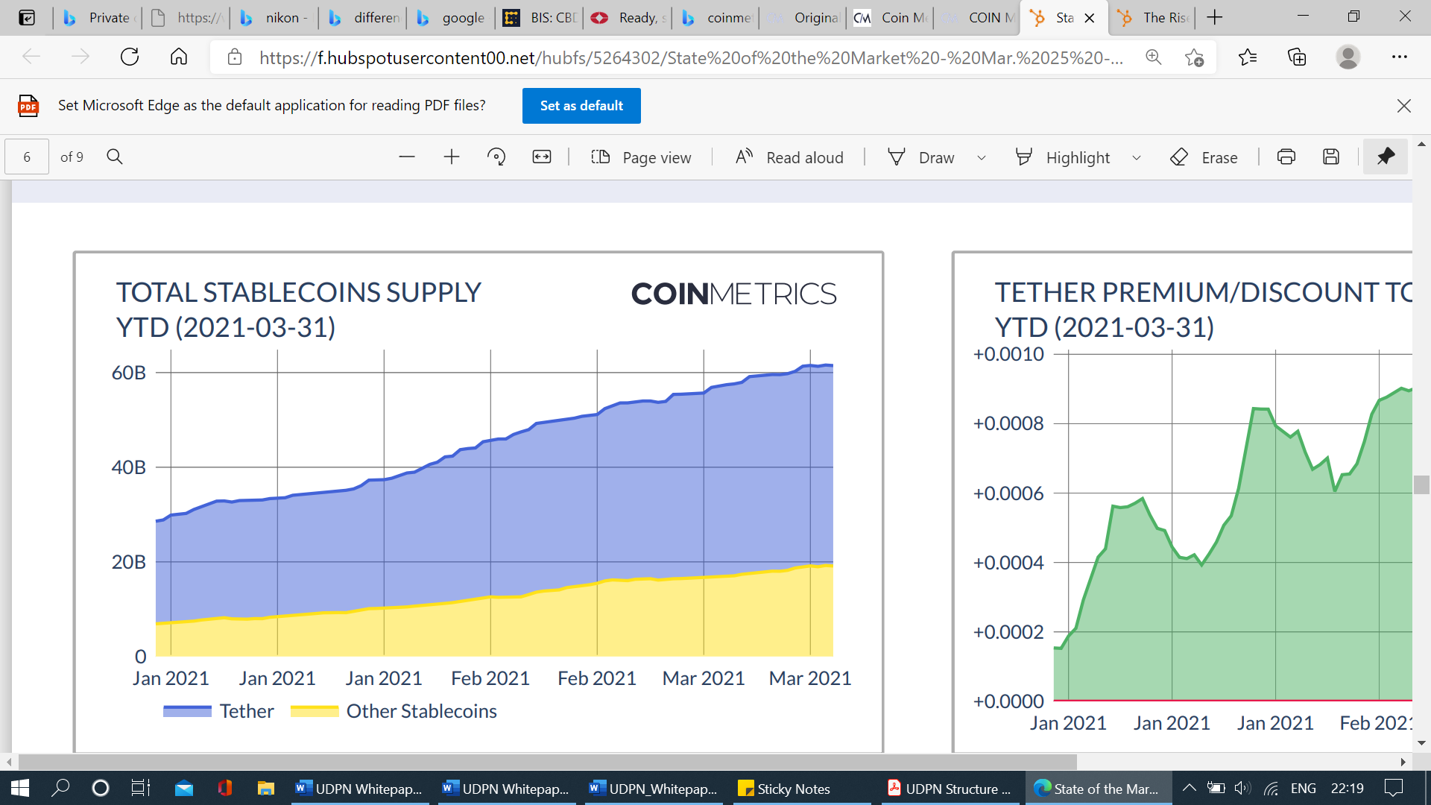

Globally, most central banks are now actively engaging in the CBDC space with varying degrees of progress. As per a BIS survey[7] of 65 central banks, 86% said they have completed some work on the topic, while about 60% (up from 42% in 2019) are conducting experiments or proofs-of-concept, and 14% of them are moving forward with development and pilot arrangements.

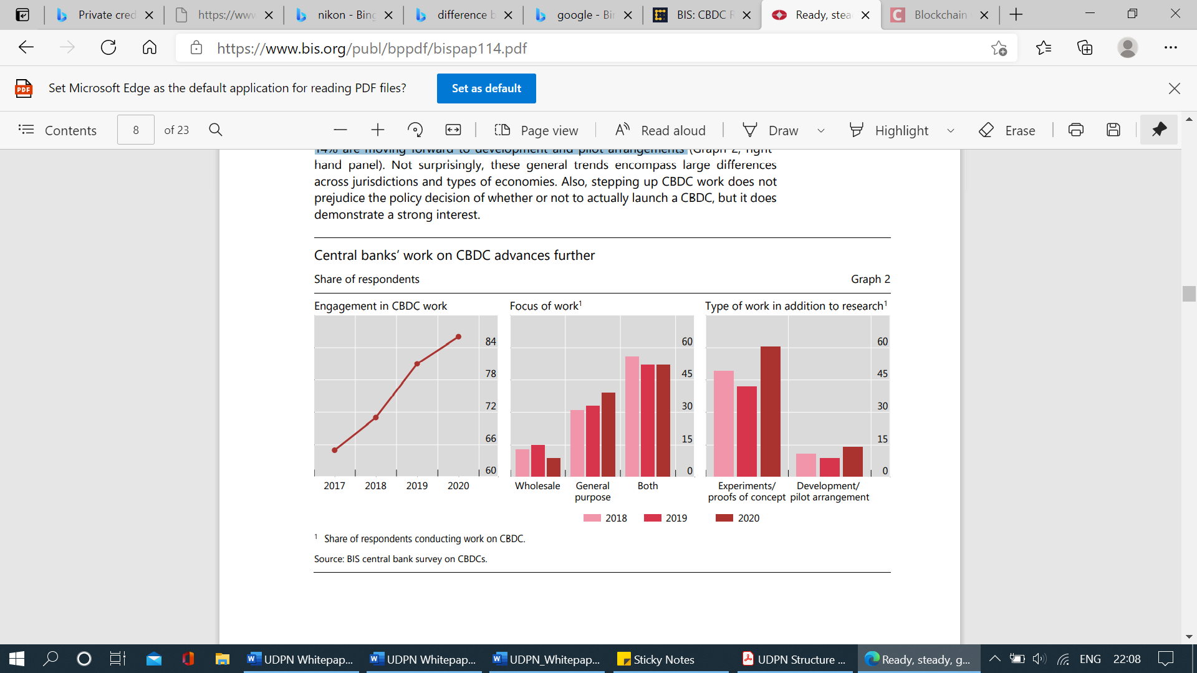

## **Objectives of UDPN**

Scalable and universal interoperability will be key to enabling efficient and smooth movement between the legacy payments infrastructure and the rapidly evolving digital currency infrastructure.

There is an opportunity to unify the fragmented ecosystems, leveraging advances in Blockchain infrastructure, to connect both regulated fiat-backed stablecoins and centralised CBDCs. The goal of the UDPN is to create a common decentralised network and associated standards to improve efficiency in cross-border payments processing. The UDPN would enable enterprises from different countries to transact and settle in different currencies by merely accessing their locally installed Business Nodes. Furthermore, the UDPN provides a way for commercial banks and regulated businesses to participate in the decentralised economy.

By leveraging enterprise DLT technology for multi-party coordination and using smart contract frameworks to automate settlement and compliance processes in all digital currency systems, the UDPN will lead the way in the next global financial settlement era.

Unlike most other digital currency projects, the UDPN will not issue any central token to be circulated on the network for clearing and settlement purposes. Instead, the UDPN will operate more like an inter-currency network, working with multiple stakeholders and becoming the messaging backbone between a variety of CBDC and stablecoin systems. The objective of the UDPN is to connect and facilitate the transfer and distribution of digital currencies globally through a wide network of regulated institutions and businesses .

A key challenge to achieving a common international infrastructure for cross-border payments centres around the creation of a governance model. Specifically, one which allows stakeholders from all countries to participate in the use, development, operation, and maintenance of the network, in a trusted and equitable way. It is therefore the goal of the UDPN to develop an inclusive framework to address the issues of governance, ownership, and participation in a network leveraging DLT technology. To achieve this goal and overcome the challenges in cross-border payments’ governance, the UDPN will be managed by an alliance of financial institutions and technology companies from different countries and industry verticals, each having shared ownership of the network.

# **2.0 Fundamental Architecture & Operation Model**

## **Underlying Framework of the UDPN**

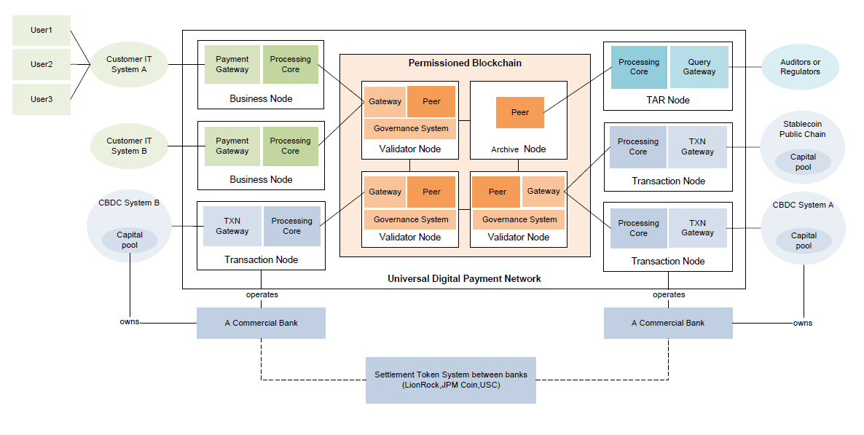

## **Permissioned Decentralised Network**

The primary objective of the UDPN is to provide a messaging layer for global cross-border payments of CBDCs and regulated fiat-backed stablecoins. With most businesses being off-chain, the UDPN structure has been built to bridge the business systems with centralised CBDC and decentralised stablecoin ecosystems, using Hyperledger BESU as the permissioned framework.

The foundational architecture of the network is a permissioned, decentralised network of on-chain Validator Nodes, engaging with off-chain Business and Transaction Nodes. Off-chain Transaction Nodes operated by commercial banks will securely connect Central Banks and stablecoin systems issuing digital currencies to the UDPN, while Business Nodes will allow any type of business system to connect to the UDPN. In addition, the on-chain TAR (Transaction Audit and Reporting) Node facilitates the work of Regulators and Auditors in monitoring the transactions of their respective digital currencies.

The UDPN is primarily a messaging platform and does not compete with currencies in circulation, nor does it issue tokens. It will have digital IDs (DIDs) linked with the digital wallets or accounts in the corresponding public chains or CBDC systems. All transactions are performed within each currency system and shared data is kept to a strict minimum (maintaining the privacy of the End users). With the UDPN network being light on data, the goal is to have the network support at least two thousand transactions per second upon launch.

The UDPN will only support CBDCs and regulated fiat-backed stablecoins as payment methods and will not support transactions involving any unregulated, public-chain, cryptocurrency such as Bitcoin. All transactions will still occur within each CBDC or stablecoin system. For this reason, the UDPN Validator Nodes do not provide any custodial services or hold any digital currencies themselves. Instead, the UDPN network provides a universal messaging and interoperability services for regulated fiat-backed stablecoins and via its network.

The Validator Nodes will operate under the assumption that the transaction and settlement information provided by digital currency holders is true, accurate, complete and genuine. As they rely on digital currency holders for the accuracy of the information provided, the Validator Node operators can bear no obligation, nor liability in this regard.

The UDPN architecture is robust and built with security in mind. The data-driven framework enhances performance of the transactions and ensures that the infrastructure adheres to the highest standards of operational resilience. The UDPN will deploy an integrated and comprehensive approach to mitigate any challenges to the network, and ensure the system is reliable, resilient and efficient at all times. The network will be subject to regular and stringent contingency tests, to ensure continuity of operation.

In addition to business continuity planning the multi-layered frameworks counter any system disruption, ensuring that backups are always in place. The system design is modular and scalable, allowing it to serve an ever-increasing number of participants and transactions. UDPN stakeholders will be engaged in the ongoing risk management of the network to ensure the resilience of their systems and compatibility with all UDPN upgrades and risk management measures.

## **Stakeholders and Node Types**

The UDPN does not serve individual consumers directly, but rather provides digital infrastructure core services to third-party businesses and financial institutions, who can build applications involving digital currency payments. These third-party businesses and financial institutions are the primary clients of the UDPN. Any business will be able to facilitate transactions in CBDCs and regulated fiat-backed stablecoins by installing anUDPN Business Node.

Third-party businesses include any type of business, from commercial banks and IT Vendors to E-commerce players and fintechs who are facilitating payments. The exchange of regulated fiat-backed stablecoins and CBDCs will be facilitated through capital pools managed by licensed money service providers, such as commercial banks and regulated businesses. The UDPN network itself will not directly operate any capital pools.

## **UDPN Decentralised Identity (DID)**

Each user on the UDPN is required to have a decentralised ID (DID), which is then linked with accounts and wallets on the CBDC and stablecoin systems. To achieve this, the UDPN grants the rights to any business node to create DIDs, request the linking/delinking of wallets, and to initialise digital currency transfers and swaps through the network.

Business IT systems can operate Business Nodes after receiving permission from Validator Nodes to become an access point on the UDPN. In order to onboard end users, the Business Nodes will need to create unique UDPN digital IDs (DID) and link these DIDs with existing accounts and wallets on the digital currency systems. The Business Node operator can choose to just use its own DID as the money processing ID and build one layer of user accounts on top of it. In such instances, one DID can serve many, even millions of end-users’ and digital currencies can be easily transferred and swapped between UDPN DIDs, using the best-matched FX rates for the transactions.

The decentralised UDPN network will create a digital identity contract that will have the details of the DID and provide DID services to UDPN network members. A DID resolver will provide a DID resolution service which connects to the Digital Identity Foundation (DIF) Universal Resolver.

User credentials are securely stored in the identity hub within a Business Node. An issuer registration service will be enabled to publish the UDPN network member list and the Transaction Node owner list, along with their issuable credentials. The other functions of this service include input, delete and query of the issuer information. To maintain data privacy, the personal information of the end user will not be included in the DID. Only business IT systems have the personal information of the end users that they onboard, as part of their relevant KYC process.

Lastly, a credential issuing service will be enabled to define unified, standard, credential issuing service APIs. Issuers (UDPN alliance members and Transaction Node owners) will implement their credential issuing services independently. The main APIs include those used to apply for credentials, obtain application results, and query a credential revocation list.

## **UDPN Nodes**

Using a permissioned distributed ledger Blockchain network interfacing with an off-chain payments network, the UDPN structure will have participants connected to it via a structure of four main nodes: Validator Nodes, Transaction Nodes, Business Nodes, and a Transaction Audit and Reporting (TAR) Node. Each Node has a distinct set of attributes and is run by different stakeholders, respectively.

The UDPN permissioned network has four main nodes: The Validator Nodes and TAR Nodes are on-chain while the Business and Transaction Nodes of the UDPN are off-chain. The Validator Nodes contain the Hyperledger BESU peer, validator and governance systems, with the TAR Nodes containing the BESU Archive Node. In every node, digital identity services integrate UDPN DID client SDK to achieve DID management, DID resolution, issuer registration services, credential management, and data encryption storage management.

1. **Validator Nodes:** The Validator Nodes are at the heart of the UDPN. Any transaction on the UDPN will be validated by a cluster of Validator Nodes which are connected with all the other stakeholders via a secure and encrypted connection. The Validator Nodes and TAR Nodes are the only ones which store the full set of transaction data on the UDPN. Transaction Nodes are owned and operated exclusively by the UDPN Alliance members.

It must be noted that a Validator Node only validates the format of the message received from a certified Business Node. Upon receipt of a message, the Node validates the veracity of the signature and message origin. It does not however validate the content of the message. The content is only validated by the currency systems, depending on the nature of the transaction. Each transaction submitted from the Business Nodes will be randomly assigned to certain Validator Nodes to validate. All transactions are validated and written to the peer of Validator Node which reads, endorses, and writes transactions to the distributed ledger Blockchain ledger. The Validator Nodes are connected to the Business and Transaction Nodes through secure APIs.

Each Validator Node’s operations are conducted with full autonomy. The UDPN has no controlling entity but is governed by means of a majority voting. All the Validator Node owners will have the right to vote on such topics as network access permissions, the performance of software updates, the approval of new smart contract deployment and adjustments to fee structures.

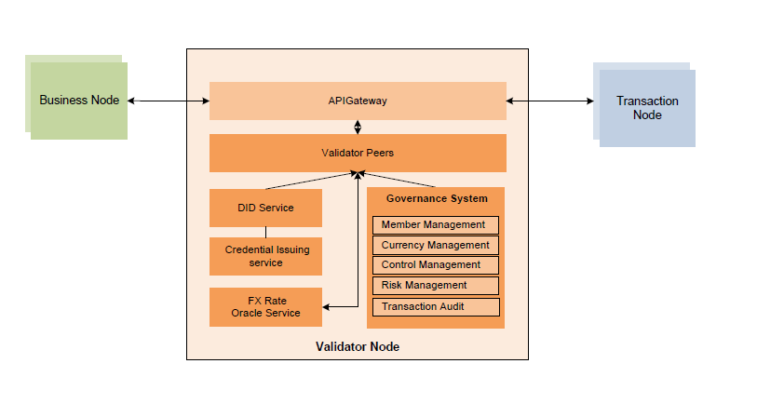

All Validator Nodes contain a governance system that ensures adherence to the rules of the UDPN. As there will be multiple Validator Nodes in the network, with more being added as the alliance grows, not all Validator Nodes are required to participate in the same transaction.

Validator Nodes should be installed in the members’ own cloud account or on-premises infrastructure. As part of the Validator Node installation, each member will also install the UDPN governance software.

1. **Business Node**: The end users interact with the UDPN through Business Nodes owned and set up by third-party businesses who wish to integrate UDPN services to their business systems. All Business Node owners must undergo a strict KYC check before connecting to the UDPN. Like the Validator Nodes, the code for the Business Nodes is open source, and any software engineer can download the code and install it on their company’s systems locally.

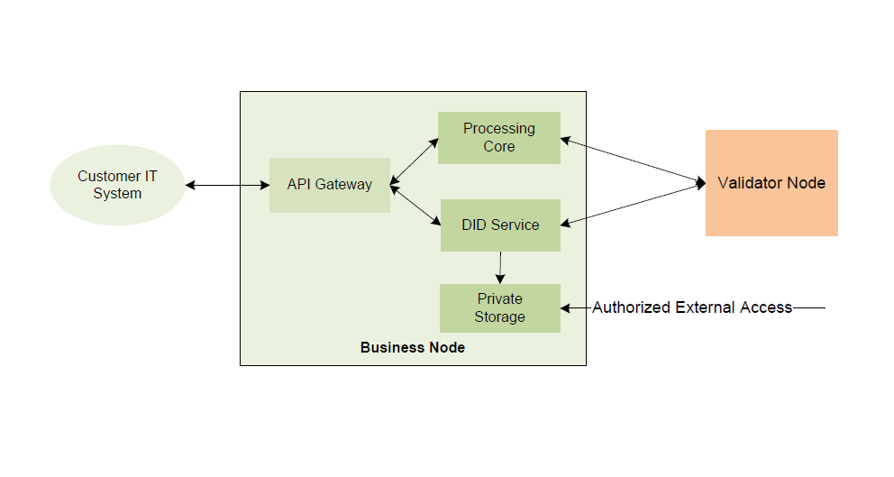

To install a Business Node, businesses need to submit an application. Once approved by the Validator Node’s governance system, the Business Node is added to the UDPN and connected to the business IT system. A certificate and a DID can be created for a Business Node after the Validator Nodes’ approval. .

Each Business Node contains a gateway and private storage (encrypted by a Business Node private key). Business nodes will only store their own UDPN transaction data.

The third-party businesses’ IT systems must use gateway APIs to access the Business Node. This API gateway provides unified digital identity management and payment transaction processing services to the Business Node operators.

Private storage contains the credentials issued by the UDPN issuer or currency systems along with storing off-chain private data, such as that related to KYC. To access credentials, other DIDs need to be granted permission by the Business Node owner.

The node uses a digital identity service to integrate the UDPN DID client SDK. In order to conduct payment services, the node will interact with the UDPN network to initiate a currency transfer or swap request and to support the querying of the state of its own transactions.

1. **Transaction Nodes:** These nodes are custom made for each currency. There may exist multiple Transaction Nodes for each currencyto handle a high volume of transactions. Transaction Nodes connect all UDPN stakeholders to the currency systems and can only be operated by regulated businesses, primarily commercial banks, money service providers, and regulated fintechs.

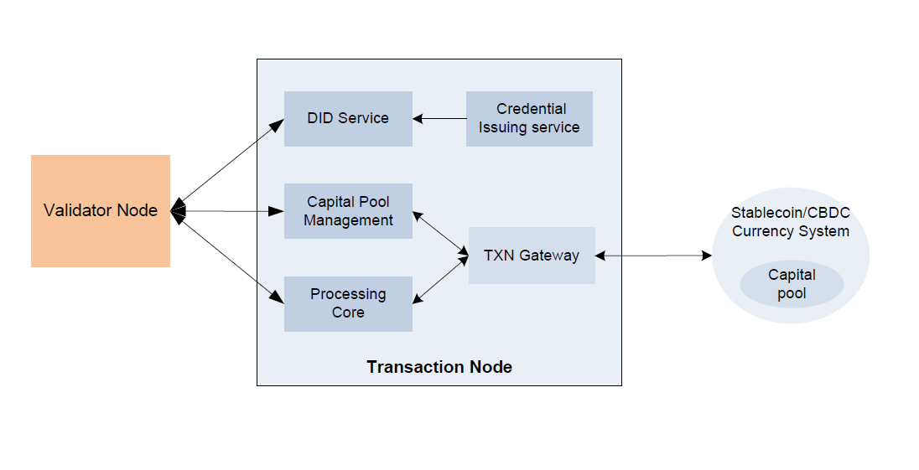

Each Transaction Node will contain a capital pool management module for currency swap operations, thereby providing deep liquidity for all currency pairs. They will connect to the digital currency systems through the transaction gateway for transfer, transaction and query results.

For each currency on the network, customised development is required based on the respective currency system requirements for verifications and transactions. Once a transaction that has been initialised on the UDPN is validated, it will be passed to the corresponding digital currency system to process via the Transaction Nodes. For account-linking operations, the relevant Transaction Node will issue a signed certificate and the related Business Node will store these credentials once the currency system successfully verifies the ownership of the account.

The requests and responses regarding certificates will be handled off-chain and enhanced by multiple layers of secure processing. It is worth noting that both the Business Nodes and Transaction Nodes store only the data that they have processed and not the rest of the network data. This approach enhances data privacy and increases transaction speed.

1. **Transaction Audit and Reporting (TAR) Nodes:**

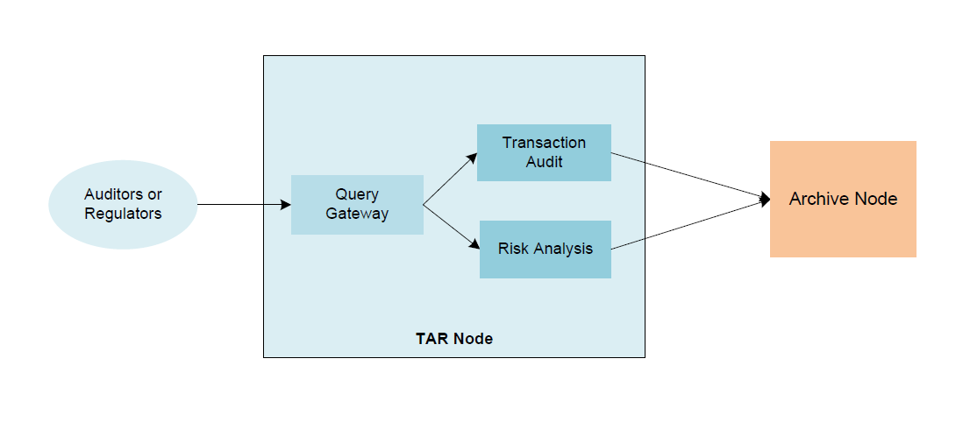

The TAR Nodes are installed on-demand to facilitate the work of Regulators and Auditors in monitoring the transactions. Regulators and Auditors are allowed to query data from the Archive Nodes. They can also install applications on top of the TAR Node to further ease transaction monitoring and Risk Analysis. The TAR Nodes can only query data and cannot input any data onto the network.

The TAR Nodes hold the same data as the Validator Nodes. This data does not include any end user personal information other than DIDs, currency types, transaction amounts and some scrambled currency account numbers. Authorities must therefore also seek permission from their own currency’s Transaction Node owners in order to gain access to any additional data.

## **Smart Contracts**

Each operation on the UDPN is defined by a set of smart contracts, which enable the automation of settlement and compliance processes. The UDPN supports Solidity smart contracts, which are deployed to a Hyperledger BESU permissioned network. Any new business operations can be added through the deployment of new smart contracts. These smart contracts can only be deployed and updated on the UDPN upon receipt of approval from the operators of the Validator Nodes.

The smart contracts are deployed across a host of activities and transactions which include:

* DID contract
* Issuer registration contract
* Account or wallet linking/delinking contract
* Currency registration contract
* Payment processing contract
* FX Exchange order-matching contract
* Authority Management contract (for access control)
* UDPN governance contract
* Revenue distribution contract

## **Revenue Model**

In the initial stages, the UDPN will not charge users, and thus allow more users to experience the platform and overcome any frictions. Following the initial phase, the UDPN’s primary revenue streams will be derived from the fees generated by swaps and transfers, which will be automatically charged on the system to users of the UDPN. The revenue will be distributed to alliance partners directly, via on-chain smart contracts.

## **3.** Transaction Flows

The UDPN facilitates the flow of payment transactions through a combination of on-chain and off-chain processes, with only the Validator and TAR Nodes being on the permissioned ledger. As previously mentioned, the end-user engages with the UDPN via the business IT systems.

There are four main types of transactions that can be conducted on the UDPN network:

1. Creation of UDPN decentralised IDs (DID)
2. Link/unlink of CBDC and stablecoin wallets with the DIDs
3. Execution of digital currency transfers & swaps
4. Providing refunds in case of failed cross-currency swaps

As the UDPN evolves, more services and operations can be added in the future.

## **Creation of UDPN DID**

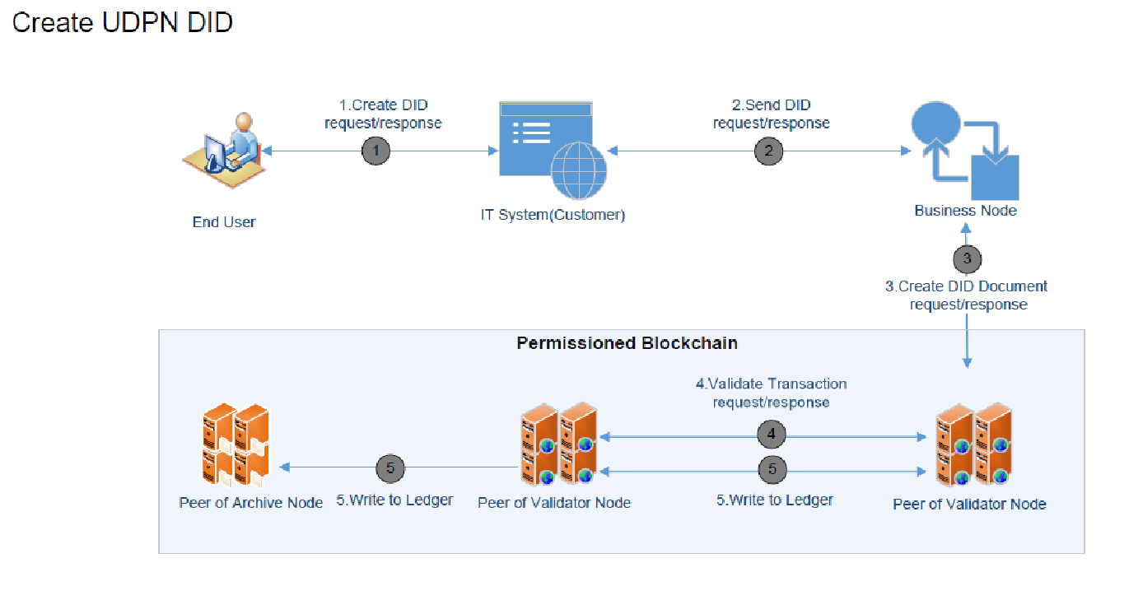

To perform any payments through the UDPN, all users must first create a unique UDPN DID . To initiate the DID creation process, the end user or business must submit a DID request through the off-chain IT System of the UDPN Business Node.The UDPN provides the business IT systems with the flexibility to either create a DID for every end user, or to use a single DID with a user layer on top. In the case where the business IT systems build a user layer on top of a DIDall users can effectively use this single DID for all transactions. If users prefer to own their private keys, the Business Node owners can let them generate private keys on their own. The Business Node owners will decide themselves which model to use depending on their own business use cases and requirements. The DID documents are maintained on-chain, enabling end users to use the same DID on different Business Node-related systems. DID documents do not contain any personal information.

## **Linking/delinking CDBC and Stablecoin Wallets**

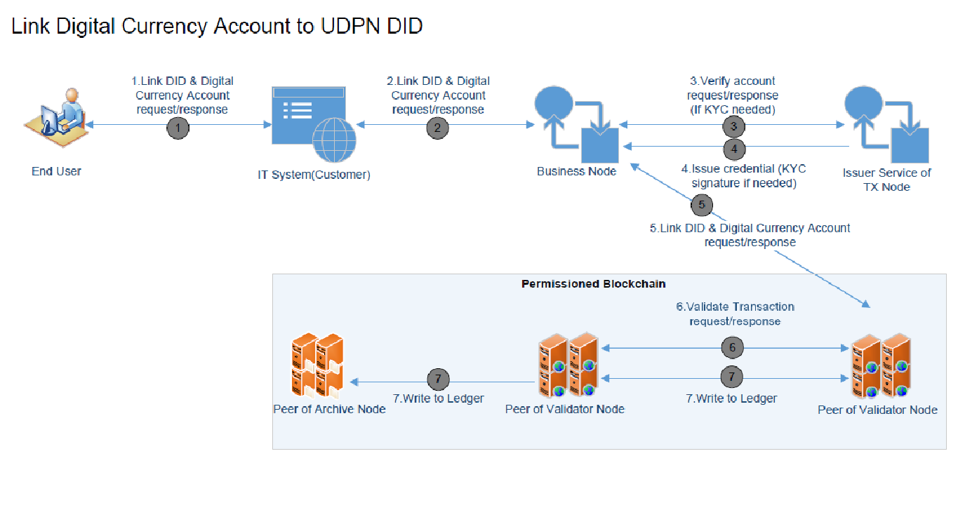

After a UDPN DID has been created, the end user can proceed to link their DID with their digital currency accounts or wallets. Linking a CBDC and stablecoin account to a DID will allow users of the DID to make transaction (transfer or swaps) requests via the UDPN network. After a user delinks her account from her DID, she will not be able to use her DID to make transaction (transfer or swaps) requests via UDPN.

## **Digital Currency Transfers & Currency Swaps**

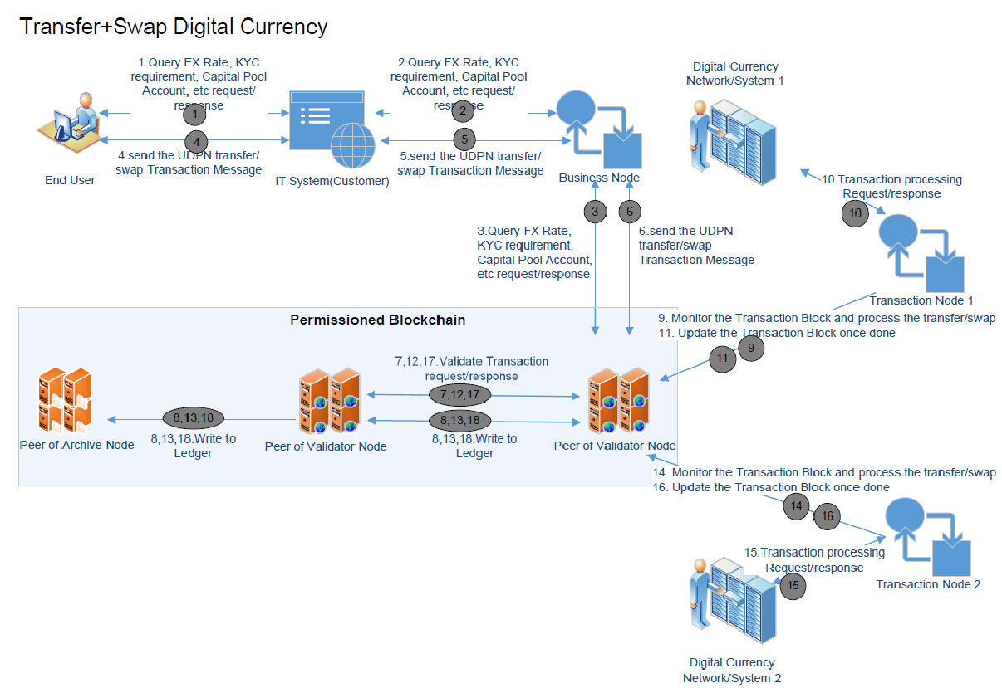

When a transaction (transfer or swap) is initiated via the UDPN, the Business Node compiles the transaction messages and each message is then passed onto the Validator Nodes. During this transmission, the Transaction Node will monitor the data on-chain, verify the sender signatures (or KYC and credentials if required), and process the transfer or swap by submitting the transaction request to the respective digital currency systems. All transaction requests use the same set of smart contracts for execution purposes. If the currency types are different inside the transaction request, a swap process is initialised.

The swap process consists of two transfer processes involving the capital pools of different currencies. Let us take for instance a 100 digital Euro to digital US Dollar Swap. Whenever an FX exchange is initiated, the UDPN receives a swap request message from the sender’s IT system via a Business Node. The sender’s 100 digital euros will be debited from her personal account to the Euro capital pool. Subsequently, the message is sent to a corresponding digital Dollar Transaction Node, via the Validator Nodes, at the prevailing FX rates. The digital Dollar capital pool will then deposit the equivalent of 100 digital euros in digital dollars into the sender’s digital USD account at the prevailing exchange rate, thus completing the swap.

The FX rates are maintained in real-time via an order-matching system operated by third parties or by Transaction Node operators. When dealing with regulated fiat-backed stablecoins, network fees (gas fees) will then be issued to UDPN administrative accounts or capital pools. In the case of a currency swap, the fees will be included as one transaction from the originator's account to the capital pool.

## **Refund Process in the case of a failed transfer**

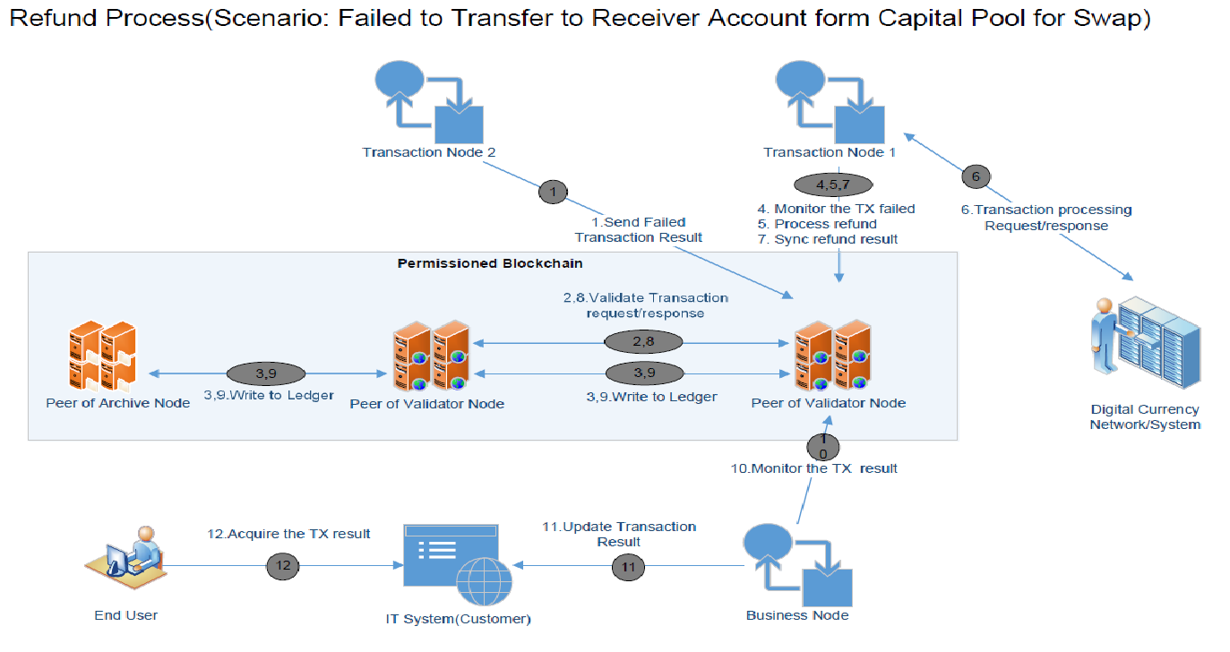

In instances where the system fails to transfer the receiver’s currency from the respective Capital Pool to the receiver’s account, a refund is initiated. In the above instance of an FX swap between digital euros and digital dollars, funds from a Euro Capital Pool would be returned to the sender’s account if the digital USD transfer failed.

It must be noted that there is no refund, per se, for same-currency transfers. For refunds in the case of a successful same currency transfer, the receiver needs to make a new payment transaction to the original sender.

**4.** Wholesale Digital Currency Settlement

When a Business System wants to initiate a transfer from one currency to another, the commercial banks and regulated businesses operating the Transaction Nodes need to have accounts with the relevant Central Banks and have capital in the Capital Pools.

For example, let us say that a sender, ‘Business System A’, wants to convert a Ddgital dollar into a digital euro. In order to process such FX transactions, the commercial banks and regulated businesses facilitating the foreign exchange service will need UDPN capital pools in the relevant currencies, and so require accounts at the Federal Reserve and the ECB. When an FX transaction is initiated, the digital dollar is moved from the sender account to the Dollar Capital Cool held by ‘Commercial Bank A.’ Next, an equivalent number of Digital Euros are transferred from the capital pool held by ‘Commercial Bank B’, to the beneficiary’s Digital Euro account. The FX rate will be based on real-time exchange rates.

The ‘Commercial Bank A’ that now holds the digital dollar received from ‘Business System A’ will use a third-party, wholesale digital currency settlement token to settle with ‘Commercial Bank B’ who made the pay-out to ‘Business System B’. Commercial banks and regulated businesses will need to be enrolled with the respective wholesale currency token settlement systems in order to participate.

Commercial banks have spent considerable resources on improving wholesale use cases of digital payments. Examples of such projects include JPM Coin by J.P. Morgan and Fnality Global Payments by Fnality International. Central Banks are also collaborating on the cross-border payment topic as illustrated by Project Dunbar led by the Monetary Authority of Singapore and the Bank for International Settlements, as well as the m-CBDC Bridge jointly led by the Hong Kong Monetary Authority, the Bank of Thailand, the People’s Bank of China, the UAE Central Bank, along with the Bank for International Settlements. The UDPN is an interoperable infrastructure that allows all retail digital currency systems to connect with end users, through a common messaging system.

# 5. Security and Privacy

In a world where cybersecurity attacks on financial networks are increasing, centralised hub-and-spoke models are particularly vulnerable. Security is paramount for all organisations joining the network. Moreover, the UDPN Alliance understands that AML, CFT, financial sanctions, and the prevention of illicit activities at a network level are front of mind for compliance and risk departments within financial institutions.

To ensure that the UDPN adheres to the highest possible standards, security frameworks such as ISO 2700X series and NIST are being used as a reference. The goal is to guarantee security, ensuring that the principles of CIA (**Confidentiality**, **Integrity** and high **Availability** of data) are met.

## **IT Security**

The following are the key elements of the network & IT security, which will use the CIA principles to ensure robust security across the UDPN network:

* **Security by using a DevSecOps approach**: The UDPN is defining, implementing, and continuously improving its own System Development Life Cycle (SDLC) in order to integrate security testing and automation into the software development lifecycle. In this regard, a DevSecOps approach will be used in order to automate integrated security testing into process and enter into a continuous improvement loop. In doing so, security automation is increased, and the risk of human error reduced. Top IT security specialists have been engaged throughout the project since its inception and during all of the SDLC. This SDLC flow applied in the UDPN will be complemented with security testing and security test automation.
* **Security in layers:** The UDPN network will have a variety of parties, engaging both internally, as well as externally. The relationship between different parties within the UDPN is not that of client-provider. Actors in the UDPN can be considered members of a *supply chain* in terms of security as every party involved is providing its own infrastructure and individually managing the IT security of the nodes for which they are responsible.

The UDPN will establish a security governance mechanism that ensures the security of the whole system, with technical standards being provided to all participants. The foundation of this will be the multi-layer Security Operations Centre, which will set and govern the appropriate security requirements for each party. A dedicated CERT/CSIRT will be set up for every party (depending on its role) and have a team responsible for coordinated Security Emergencies / Incident Responses. This will be underpinned by a robust Business Continuity Management (BMC) plan, including Contingency Planning and Disaster Recovery Planning.

* **Zero Trust Model:** in order to guarantee the appropriate management of IT security and assure the implementation of the necessary security measures in production, the UDPN will deploy a Zero Trust Model. Under such a model, no part of the system is considered a “safe area” and every care is taken to protect against both external attackers and malicious insiders. This involves establishing secure communication between components (including nodes)**,** ensuring robust authentication & authorisation between components, creation of a strong proof of identity, establishing the use of physical perimeters and lastly, having robust protection against any malicious insider activity.
* **Systems resiliency**: As the solution scales, appropriate security upgrades will need to be applied. As it is a decentralised system, the UDPN will deploy SRE methodology to all components, for all parties.
* **Security & Identity Governance (in a distributed network):** A strong governance system will minimise and eliminate security concerns that may arise at any level of the network. It will also ensure adherence to compliance and regulatory measures. In place from the outset, at the start of the design phase, the governance system covers everything ranging from the governance requirements for technical standards and compliance, policies for secure operation of the network to a robust governance system for identity issuance.

When it comes to Identity Governance, Public Key Infrastructure (PKI) for node identity provisioning will be implemented and governed by the UDPN Alliance. The Alliance will strive to uphold PKI best practices and implement a secure process for issuing and revoking certificates.

In terms of security, one of the main objectives of the UDPN is to guarantee security “CIA triad” ensuring **Confidentiality**, **Integrity** and **Availability** of data. The system will be designed so that data is kept confidential and data privacy is guaranteed at any moment (in transit, in use and at rest) by using encryption managed by the parties that are taking part in transactions on the network (Business Nodes, Transaction Nodes etc.). It will implement the proper mechanisms to guarantee that the data is not corrupted or tampered and so, guaranteeing integrity. Finally, UDPN will guarantee system high availability and resiliency and the proper mechanisms to backup and restore data as part of BCM (Business Continuity Management) so data availability requirements are fulfilled at any moment.

The UDPN will need to define, implement, and improve its own SDLC in order to integrate security testing and automation into the software development lifecycle and every day operations. This will ensure that when code is developed it is done to the highest security standards and when operations are completed that they are done so in a safe and secure way. In this regard, a **DevSecOps** approach is recommended as it is aligned with the mindset of “agile methodologies” in order to automate and integrate security testing into the own process and enter in a continuous improvement loop. UDPN code will be open source and we will be encouraging the all UDPN alliance members security teams (some of the best in the world due to the security needs of financial institutions) and global security tech community to review and provide feedback on possible exploits.

The UDPN will need to cover the following areas:

* **Security-by design** to enhance the design and fully resilient network and local architectures for all areas
* **Secure development and test best practices** is fulfilled by all developers working on the project
* **SAST (Static Application Static Testing)** both in “local development” and “build and test” phases. SAST testing consist basically in scanning source code and/or binaries in order to detect vulnerabilities in all areas of the individual components and network.
* **SCA (Software Composition Analysis)** whereby libraries / dependencies used by UDPN source code are scanned for vulnerabilities on a regular basis.
* **DAST (Dynamic testing and penetration testing)** to target vulnerabilities in the runtime environment. The UDPN apply dynamic in low level environments and also in production.
* **Testing systems performance and resiliency** will be needed to be performed by UDPN in order to guarantee that the system is available, working well under the desired / estimated load conditions and being resilient to unexpected situations (such as a sudden surge in swap transactions after a new currency comes on line). One of the main goals is to boost system readiness for business continuity. An SRE (*Site Reliability Engineering*) testing approach such as *Chaos Engineering* will be used.
* **Operation of IT Security in production** including security observability, response to security incidents and Business Continuity Management.

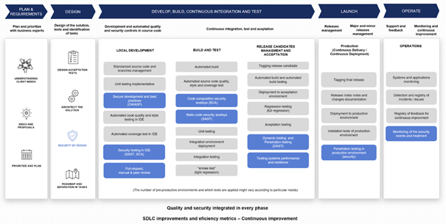

As the UDPN is a decentralized system with a large diverse of roles - businesses (owning “Business Nodes'') and regulated financial entities (owning “Transaction Nodes'') and Alliance members (owning Validator nodes) - we can therefore consider it a *supply chain* in terms of security as every party involved is providing its own infrastructure and individually managing IT security of the nodes it is responsible for.

There have been cases in systems similar to the UDPN of what is known as *supply chain* security attacks. The fact that a security issue from one of the parties can affect (in a major or minor degree) to other parties is a reality that the UDPN network is prepared for. Some infamous attacks that have succeeded due to vulnerabilities in the supply chain. In order to mitigate this risk the UDPN will define a clear terms of security management when integrating new participants and automate flags to show whether participants are using correct security procedures (the encryption of local data for eg.). A Technical Standard describing the security requirements and procedures that every party needs to fulfill according to their role in the UDPN alliance will be created defining the aforementioned standards and procedures.

## **Network Security**

In a world of increasing cybersecurity attacks on financial networks, centralized hub-and-spoke models are particularly vulnerable. Security is paramount for all organizations joining the network. The UDPN Alliance understands AML, CFT, financial sanctions, and the prevention of illicit activities are top of mind for Compliance officers and related departments within any financial institution. Our current design is regulator-friendly as we will provide archive nodes to Auditors and Regulators and facilitate access to all transaction data.

The following areas of network security will be taken into consideration:

* **Funds handling on the Network**: The UDPN Alliance and the network itself will never hold customers’ or users’ funds. Transaction Nodes can only be operated by regulated and licensed local money service providers and banks.
* **Compliance Framework:** The UDPN Alliance will ensure its compliance obligations by ensuring it meets or exceeds the regulatory requirements in the countries and regions it operates. We will implement strict due diligence processes for current and new members of the Alliance to ensure the network is used as a tool to facilitate financial inclusion and the compliant exchange of value rather than contributing financial terrorism and money laundering. Alliance members will also work together on ensuring proper programs exist to address current AML/CFT regulations and financial sanctions to create a secure environment for conducting cross-border exchanges. We will also develop financial intelligence services to prevent illegal payment activities.
* **Financial Intelligence Services & Relationship Management:** As Regulators pay greater attention to compliance and regulatory issues in the digital assets markets, it will become critical for financial institutions providing digital currency services to understand who they do business with and have proper access to their counterparties’ compliance and fraud details. Such information will be available on UDPN in the form of Financial Intelligence Services, which will be provided through our TAR (archive) nodes. At launch, UDPN users will be able to define which financial institutions they desire to do business with and will be able to deny messages from non-trusted financial institutions. Such feature does not currently exist for stablecoin transfers on public chains as these systems are permissionless by design and create significant fraud/KYC risks for any financial institution expanding their stablecoin services offering. This feature will be available within the Transaction node.
* **Due Diligence Approach:** UDPN members (Alliance and Transaction Nodes especially) will need to adhere to the highest business standards and are leaders in their respective industries. To protect Members’ reputation and client relationships, the UDPN Alliance will implement strict screening processes that will include a thorough review of prospective new Members. These due diligence reviews will be completed for all new members and on an ongoing basis to ensure the network is composed of organizations upholding the highest business and compliance standards.
* **Regulatory Considerations: The “Travel Rule”:** The UDPN Alliance will also ensure the network facilitates convenient cross-border exchange of value while providing the necessary infrastructure for network users to comply with their regulatory obligations such as the Travel rule. This rule states that all financial institutions should provide certain customer information to the next financial institution when the transfer amount exceeds a certain threshold and when the transfer involves more than one financial institution.

With the decentralized permissioned blockchain network, UDPN will interface with IT Systems and Digital Currency Issues & holders via encrypted and secure APIs. Moreover, the UDPN DID will be certificate controlled with two layers of certification, providing more security to the transaction on the network. All off-chain data sources will interact with the permissioned decentralized network via secure and digitally signed connections.

## **Privacy**

As a messaging platform, the UDPN does not store any user information, with most of the user’s personal and privacy data being stored off-chain within the business IT systems. All interactions between the end users and business IT Systems are conducted off-chain, and do not take place on the UDPN. For transactions that take place on the UDPN, only the Validator Nodes and TAR Nodes will be able to view certain details of a transaction request (in those instances without end user personal information). The Business Nodes and Transaction Nodes store their non-transactional data off-chain and have access to some KYC information where the currency system requires KYC checks.

Given that end users do not connect directly with the UDPN, but rather through business IT Systems, all personal data is stored and held by third-party businesses and not by the UDPN. The on-chain DID is always anonymous, with all KYC and credentials being stored in private storage held on Business Nodes. The assigned Validator Node is only able to validate the message format and whether the message originates from a certified Business Node. They can verify the presence of DID information, without having access to personally identifiable information. The message also includes information about the transfer amount, currency types, accounts IDs and scrambled wallet address. All end-users’ CBDC wallet IDs and account numbers are anonymised when the message is sent to the Validator Nodes. Therefore, the privacy of the end user is protected at all times.

After the message is sent from the Validator Node, the receiving Transaction Node will only decrypt the required information, to ensure compliance with applicable payment laws and regulations. Finally, it is worth noting that the data stored on the Archive Nodes is only accessible to Regulators, Central Banks and Auditors, for AML/CFT monitoring and auditing purposes.

## **Know Your Customer (KYC) Rules**

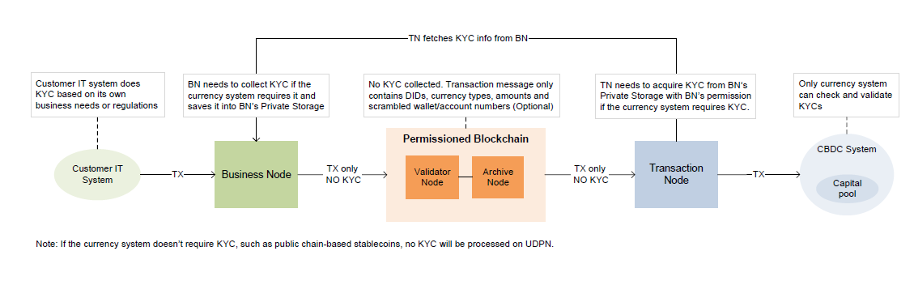

The fundamental nature of the UDPN network is that of a messaging service for digital currency transactions. Decisions regarding the legality of transactions rests with the business IT systems onboarding end users and/or currency systems. Those businesses providing end users access to the UDPN and those financial institutions operating Transaction Nodes need to ensure that transactions are compliant with relevant local and international regulations and with the currency system requirements. Failure to comply with the relevant rules may, naturally, result in the institutions facing potential sanctions and fines imposed by their respective regulatory authorities.

When an end user wants to use the UDPN network, it must first go through an onboarding process with the respective customer IT system. The IT system may need to conduct the KYC as per their business requirements or local regulations. When a transaction is initiated, the transaction request is sent from the IT system to the Business Node and subsequently to the Validator Node. This transaction message only contains DIDs, currency types, amounts and scrambled wallet/account numbers (optional). When the transaction reaches Transaction Node, the scrambled account numbers will be decrypted and the transaction is then submitted to the currency system along with KYC information if needed.

In those instances where the currency systems do require KYC, the Business Node will collect the required KYC data from the business IT Systems and save it into the Business Node’s private storage. The amount of KYC information provided by the Business Node is dependent on the requirements of the respective currency system. The Transaction Node fetches the encrypted KYC information from the Business Node and subsequently passes it onto the currency system. The currency system decrypts the KYC information and validates whether or not the user satisfies the requirement, before completing the transaction.

In the case of a swap between two currencies, should the beneficiary’s currency system require the sender’s KYC, the UDPN would require the Business Node to also authorise the receiver’s Transaction Node to access the KYC. If the currency used were an unregulated stablecoin not requiring any KYC checks, then the transaction would not be available on the UDPN.

## **6.** Regulatory Compliance

The UDPN Alliance is deeply committed to adhering to the highest compliance standards and will ensure that it meets or exceeds the regulatory requirements of the countries and regions in which it operates. Strict due diligence processes will be implemented for current and new members of the Alliance, to ensure that the network is used as a tool to facilitate financial inclusion and the compliant exchange of value, whilst prohibiting any financial terrorism and money laundering.

The UDPN Alliance and the network itself will never hold or move funds. Additionally, the Transaction Nodes can only be operated by regulated and licensed local money service providers, fintechs, and commercial banks. Working in conjunction with global authorities the UDPN Alliance members will create a secure environment for conducting cross-border exchanges: ensuring that AML and CFT risks are managed, sanctions requirements met, and all regulatory requirements adhered to.

Given that the majority of Transaction Node owners will be commercial banks and regulated businesses, they will have to follow the strict compliance and regulatory requirements of the jurisdictions where they operate. Business Node operators are required to provide the UDPN with their relevant KYC information. In addition, the UDPN will apply a “regional code” to every Business Node, based on its country and region. The UDPN will only allow Business Nodes to access currencies and enable transactions so far as is permissible in accordance with the relevant country’s laws and regulations.

Similar to SWIFT, the UDPN does not exert any control over the messages sent by Business Node owners over the network. Validating the authenticity of messages, and any related KYC information, remains the responsibility of the individual currency systems. As such, the currency systems themselves remain responsible for sanctions related screening and reporting, as well as for the application of any locally applicable laws and regulations. The nature of the digital currency messaging systems means that the network cannot itself administrate such screening and reporting, but instead works to facilitate the ease with which its users meet their own responsibilities in relation to national and international regulations.

# 7. UDPN Alliance & Governance

## **Organisation & Founding Members**

The UDPN Alliance’s primary purpose is to improve the efficiency of digital currency payments, through the creation of a common decentralised network, complete with associated standards. The UDPN provides a secure network that operates in accordance with local laws and regulations, through which any enterprise, from around the world, can perform payment transactions and settlements, in various digital currencies, simply by accessing their local Business Nodes. In order to achieve this, the Alliance will partner with best-in-class fintech providers, institutional finance partners, and digital finance experts to rapidly accelerate the development, deployment, commercialisation, and global scaling of the UDPN ecosystem.

The goal is to have eight founding Alliance members acting as the initiators of the UDPN. The Alliance members are a diverse collection of organisations representing various verticals of the ecosystem from technology firms and multinational banks to Central Banks and major payment providers. This core group forms the nucleus for an international alliance that is responsible for developing the roadmap, standards, governance, and commercialisation strategy for the UDPN. Each founding Alliance member has equal rights and is selected in such a way as to provide cross-geographical representation. The partners voluntarily invest resources into the UPDN, with core members conducting activities in a coordinated fashion. This decentralised governance structure ensures that no single party will be able to gain full control of the UDPN, and the UDPN always remains a neutral platform with equal rights for all members. All decisions are taken after voting by members, with appropriate voting thresholds set for different types of decision. There is no controlling entity, CEO or board of directors for the UDPN. This ensures that no single person, entity, organisation or sovereign government can take control of the network. The UDPN will establish a governing council, with each member having one representative. All members will take turns chairing this council on a quarterly basis.

Being an advocate of an open-source ecosystem, the Alliance will be keeping the Validator Nodes and Business Nodes open-sourced. Additionally, the Alliance members will ensure UDPN developments remain within one single codebase. All member stakeholders will have access to the codebase and any related documentation at any given time, including during the development phases.

## **Decentralised Governance and Voting**

The UDPN is jointly managed and governed through a distributed governance framework, by all Validator Node owners. Each Validator Node owner is expected to participate in the decision-making process of the Alliance and each Validator Node owner has one vote to cast to determine matters relating to the development, maintenance and operation of the UDPN. To ensure robust governance, the voting process will require a quorum to ensure the proper engagement of the majority of the Alliance members on all operational matters. .

|  |  |  |
| --- | --- | --- |
| 1 |  |  |
| 2 |  |  |
| 3 |  |  |
| 4 |  |  |
| 5 |  |  |
| 6 |  |  |
| 7 |  |  |
| 8 |  |  |

# The distributed governance system is deployed by UDPN Alliance members with Validator Nodes to vote on the UDPN roadmap, standards, governance, and commercialisation strategy and manage payment operation as well as network monitoring. . The permissioned decentralised network supports network access control and smart contract deployment management. In the network access control function, all nodes requesting access to the network need to be voted in by the UDPN alliance members to join UDPN. 8. Social Impact

The UDPN is positioned as a global payment infrastructure. The main driver of this positioning stems from the desire to bring accessible, simple, cross-border payment capability to those people who currently have limited or no access to straightforward digital payments. A sentiment that is echoed by manyCBDC projects, which often focus on increasing financial inclusion and significantly lowering costs and improving accessibility.

In many emerging economies people and businesses face a lack of access to banking services, hindering economic and social development. Those who do have access to banking services often face high transaction and account fees, coupled with slow transfer times and limited transparency. The UDPN Alliance aims to tackle this issue and to increase financial inclusion. It is keen to collaborate with institutions that are also committed to solving these issues and that are able to build user friendly front-end payment services with UDPN access.

# 9. Roadmap

The Alliance will add to its eight founding members growing gradually to 24 (each running their own Validator Node) over the next two years. The additional 16 members will include a diverse representation of Central Banks, commercial banks and technology companies. Key to the UDPN’s success will be the ongoing and continuous integration of all relevant CBDCs and regulated fiat-backed stablecoins. Focusing initially on a handful of major regulated stablecoin currency systems, our aim is to have over 100 currencies on the UDPN in a few years, making it a powerful network for all stakeholders.

Although Central Banks globally are advancing their engagement with CBDCs, barring a few exceptions, most have just started progressing from discussion stages to experimentation. With most CBDCs in early stages of development, we anticipate that the digital currency cross-border payments ecosystem will be driven by the rise of regulated fiat-backed stablecoins in the next couple of years. This provides the UDPN sufficient time in which to establish a robust foundation, so as to be the go-to platform for all Central Banks, as and when they launch their CBDCs.

In line with these expectations, the beta testnet of the UDPN is scheduled to go live with 2 to 5 regulated fiat-backed stablecoins in late 2021, with pilot commercialisation by early 2022. Subsequently, we will be targeting full-scale global deployment within two years, incorporating regulated fiat-backed stablecoins and eventually CBDCs.

The UDPN is positioned to become the global messaging backbone, connecting all CBDCs and regulated fiat-backed stablecoins. Furthermore, its design and architecture also support connections to traditional account systems, such as commercial bank accounts and payment service accounts. Therefore, the UDPN can act as a bridge between digital currency accounts, commercial banks, and payment wallets.

# 10. Conclusion

.

DLT technologies enable end-to-end transparency for Central Banks when circulating their digital currencies. It significantly increases efficiency of monetary policy, whilst mitigating the risk of failure and significantly reducing transaction costs. It also enables the Central Banks to pay benefits, grants and stimulus funds directly to individuals, especially those who are unbanked. With CBDCs, people have full control of their money through a direct account with the Central Bank while still being able to benefit from custodian services at their local commercial bank.

CBDCs empower customers to take ownership of their financial assets. Therefore, customers can now demand better terms and benefits from their commercial banks, in exchange for allowing the banks to hold their money. This could range from demanding attractive interest rates, to tailored services and significantly reduced fees. There will be a significant level of competition as banks and fintechs jostle to adapt their service offerings in a bid to acquire and retain customers.

Commercial banks are coming to a critical turning point in the evolution of the global financial system. They are reinventing their business models to remain relevant to their customers and profitable. Engagement with the UDPN provides commercial banks with an opportunity to remain an integral part of the future financial ecosystem. They will be essential participants in the UDPN by servicing capital pools and engaging withCentral Banks to provide liquidity for cross-border transactions. With multiple CBDCs being created on different underlying technology protocols, UDPN allows its users to transfer value across digital currency systems while providing settlement and order-matching services to Transaction Node operators. . Through the UDPN, multiple CBDCs can be easily integrated for seamless and fast cross-border payments, globally.

The UDPN’s ethos centres around collaboration, and financial inclusivity underpins its design for the infrastructure of the future. The next steps for the UDPN will be to focus on testing the network’s full capabilities, proving the robustness and security of the systems. The UDPNs influence and impact on the furthering of decentralised finance, and the digital economy, will continue to grow, as more regulated digital currencies are added, and additional Alliance members join.

The technologies underpinning the decentralised financial system are constantly evolving, with rapid improvements taking place on a regular basis. These pioneering technologies are revolutionary for financial services, and the UDPN is exploring how best to improve people’s lives and contribute to the industry. Continued innovation and competition will be key to driving increased efficiency and lowering costs.

We would like to invite like-minded institutions and experts to collaborate with us and to be part of this transformational moment in financial history. No system is perfect, and as we scale the UDPN in this complex world of fast-evolving technology and strict and varying regulatory environments, there are bound to be areas in which our network can be improved. We are a collaborative body that endeavours to learn from global experts in order to challenge our limitations and continually improve the UDPN system, ensuring its place as the world’s principal digital payment messaging network.

Reach out to the Alliance to contribute to our mission to build an inclusive, low-cost, fast and easily accessible global payments ecosystem.

1. McKinsey (2018) https://www.mckinsey.com/industries/financial-services/our-insights/a-vision-for-the-future-of-crossborder-

   payment
2. https://www.knomad.org/data/remittances
3. UN World Tourism Organization (2020). https://www.unwto.org/world-tourism-barometer-n18-january-2020
4. [ttps://www.worldbank.org/en/news/press-release/2019/04/08/record-high-remittances-sent-globally-in-2018](https://www.worldbank.org/en/news/press-release/2019/04/08/record-high-remittances-sent-globally-in-2018)
5. <https://think.ing.com/articles/not-even-a-global-pandemic-can-shift-preferences-for-cash-as-an-option>
6. <https://www.bankofengland.co.uk/paper/2020/central-bank-digital-currency-opportunities-challenges-and-design-discussion-paper>
7. [Ready, steady, go? – Results of the third BIS survey on central bank digital currency](https://www.bis.org/publ/bppdf/bispap114.pdf)